CS 340 README

About the Project/Project Title
Grazioso Salvare is an organization that trains rescue dogs for search and rescue operations. They need access to the animal shelter database so they can identify and select potential candidates. This project provides a Python-based CRUD module connected to MongoDB that allows efficient access and management of that data.

The database supports Create, Read, Update, and Delete (CRUD) functionality so records can be added, retrieved, modified, and removed as needed. This is important because it allows the client to interact with the data without directly working in the database.

Using CRUD functionality to connect Python applications to MongoDB was the main focus. This allowed a client-server style setup where Python acts as the interface and MongoDB handles the data storage.

Motivation
The motivation for this project was to practice organizing and managing data using a secure and reusable database application.

CRUD operations are important because they allow data to be created, accessed, updated, and deleted in a controlled way. These operations are used in almost every database-driven application and are important for maintaining usability, efficiency, and scalability in software systems.

This project helped build experience working with MongoDB, Python, authentication, and modular code design.

Getting Started
Starting off, the environment needed to be set up so the records could be imported. A DB named aac was created in the past. Then the dataset aac_shelter_outcomes was imported into the DB. A user was created for authentication and access to the sensitive data. The system then required access to aacuser via a personally selected password.

After the setup, the create function inserts a new document into MongoDB. The read function retrieves the documents via the query. The functions are both handled via the python class AnimalShelter.

Once the access was verified, the code could be completed along with the Jupyter testing scripts. Each script was run 1 by 1 until the code was fixed and no errors were received.

Installation

Python – language used to writ and run the CRUD module.
MongoDB – DB used to store animal records
Pymongo – library to connect python to MongoDB
Bson.objectid – used to handle mongodb documents

Usage
The module uses specified classes to interact with the database. For this project, AnimalShelter class was used.

CRUD Function:
C(create()) – places new record into DB
R(read()) – retrieves data based on query
U(update()) – updates existing records
D(delete()) – removes records from DB

Code Example
. 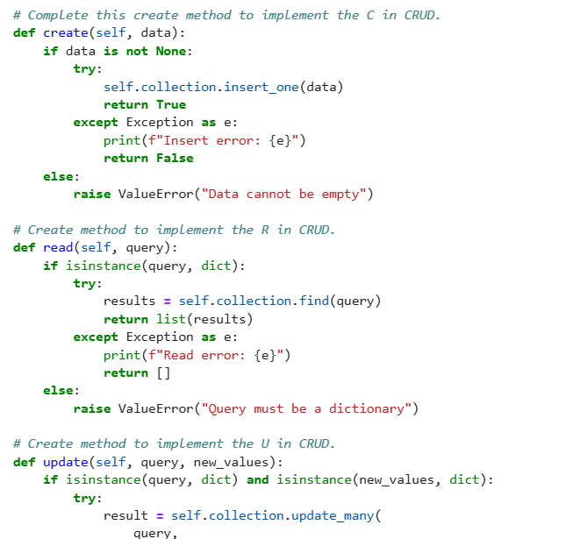
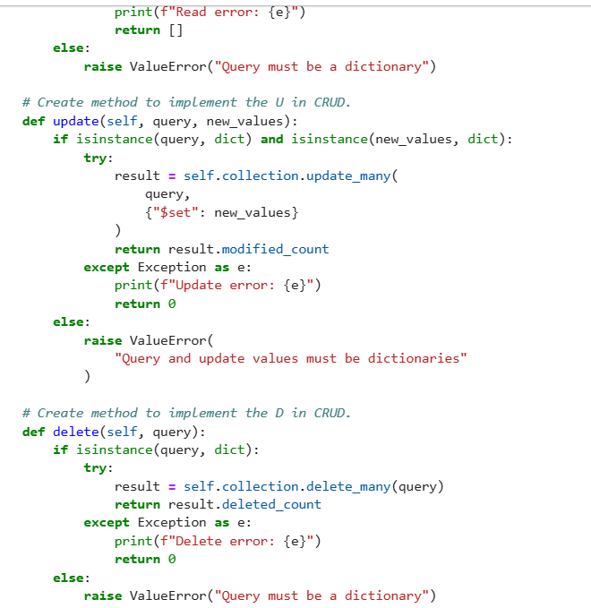

Tests
Import,
Instantiate class
Clean data
Use sample/”dummy” data
Test all CRUD methods , verify methods
Ensure user cannot place any data into the system, the system should thow errors at incorrect syntax.

Screenshots
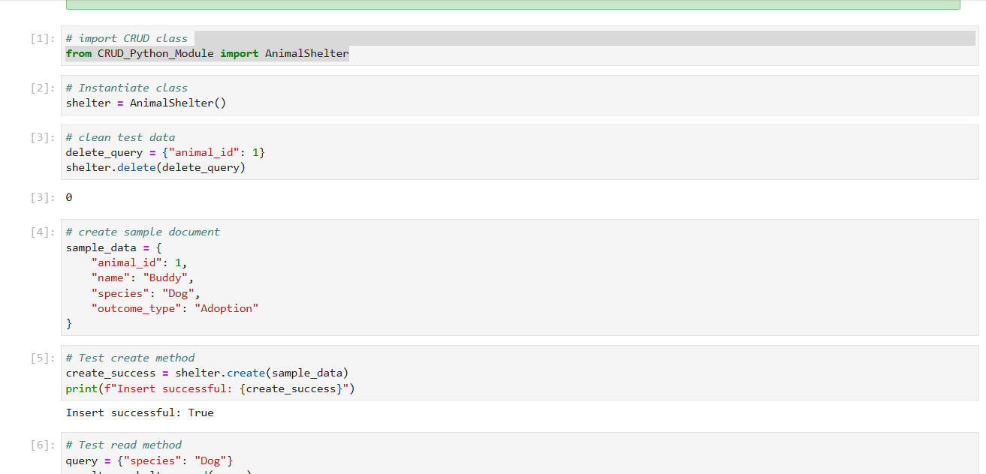
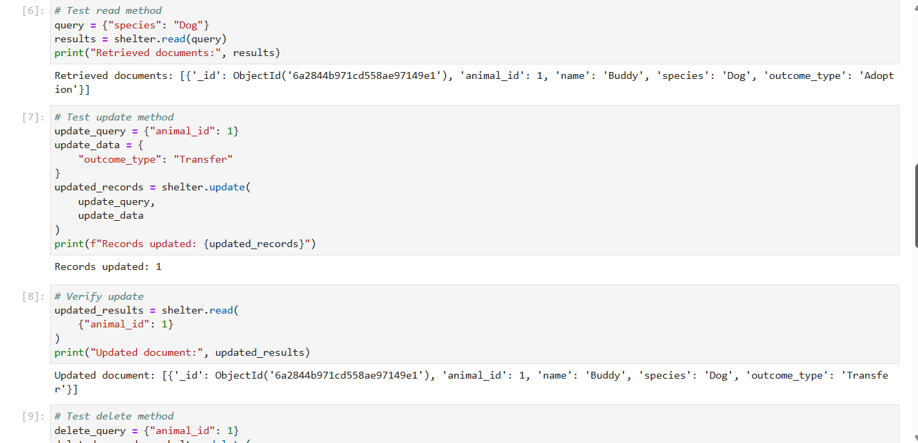
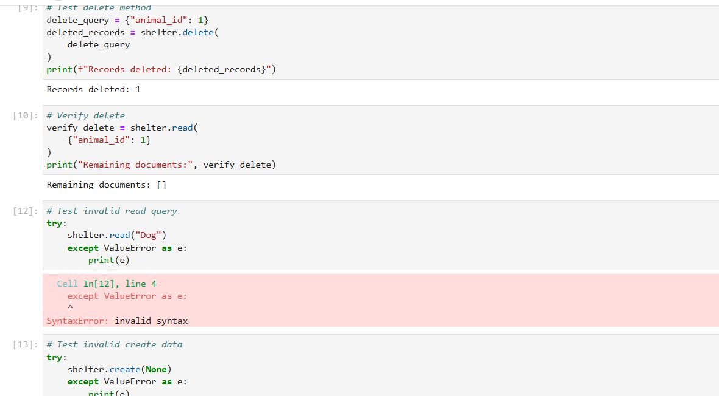
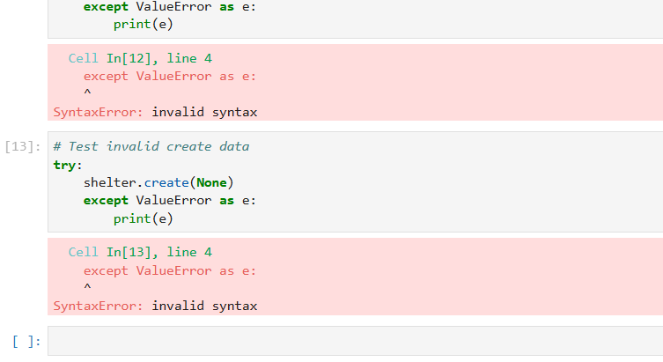

Roadmap/Features (Optional)
There should not be so many hardcoded instances – this is not best practice. Additional input validation would be beneficial to the testing as well.

Contact
Your name: Kaitlyn OConnell

